Research Template

USING THIS TEMPLATE

To edit this template you can either:

Download as a .docx file to edit using through a word processor by tapping ‘File’, ‘Download’ and ‘Microsoft Word (.docx)’  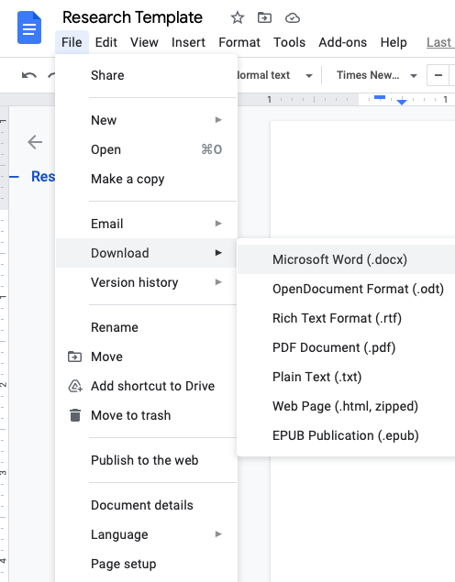 | Making a copy to continue using Google Docs by tapping ‘File’, ‘Make a copy’ and saving it on your drive.  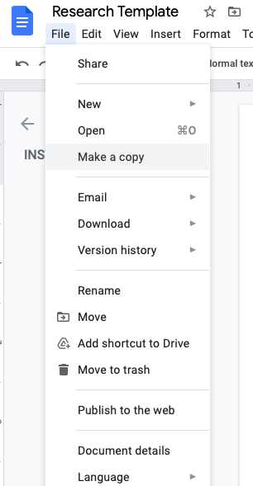

RESEARCH TEMPLATE

Note: This template is merely suggestive, delegates are encouraged to edit the template as they see fit and research beyond the prompts given. These prompts only serve to strengthen preliminary research and are by no means exhaustive.

Country
Committee
Agenda
COUNTRY PROFILE
Geography
Capital
Population
Continent
Access to Seas/ Oceans (if any)
Bordering Countries
Add a political map
Add a geographic map
History & Politics
Independence Status (if it was a former colony include- date of independence and coloniser country- history in brief)
Political Regime Type and structure of the government
Describe the Legitimacy/ Stability of current administration
Head of State
Major Events in the past five years
Culture & Society
Official Language(s)
Demography (Include ethnic groups, religions practices, economic status, etc)
How does the demographic composition affect Politics
How does the demographic composition affect society
How does the demographic composition affect the economy
Economy
GDP
Debt
Dependency (Energy, Food, Water, etc)
Primary Industries (Agriculture, Mining, etc)
Secondary Industries (Manufacturing, Processing)
Tertiary Industries (Tourism, IT, Enterprise, Finance, etc)
Other important economic resources
MEDC/ LEDC
The economic blocs and organisations, the country is a part of
Strategic trading partners
Military & Defense
Describe the status of the national military
Name military alliance the country is a member of (if any)
Nuclear Weapons Status
Diplomacy & Foreign Policy
Year of becoming a UN Member
UN Member Status
Security Council Member Status
ECOSOC Member Status
Name the organisations/ blocs other than the UN)
the country is a part of and its position and role in it
Policy towards neighbour states
Policy towards other countries
Additional Information
Any other relevant information about the country
COMMITTEE PROFILE
Background
Location of Head Office
How does the organisation describe itself
Official objectives
Budget of the organisation
Country role in the organisation
Committee Actions
What are different initiatives led by the organisation (Specify the different fields)
Areas of these initiatives (Give a few examples)
Impact of these initiatives (Include statistics and examples of how these initiatives ameliorated an issue/ issues)
Committee Resources
What monetary resources does the organisation require?
What material resources does the organisation require?
What other resources does the organisation require?
Partners
Name the organisation’s key partners
Describe the roles of these partners
What do these partners plan to do in the future
Future Actions
What are the kinds of interventions that the organisation would like to set up in the future?
Is there anything the organisation requires in order to do this?
Additional Information
Any other relevant information about the committee
AGENDA & COUNTRY POSITION
Background
Describe the issue briefly
Keywords/ Key Terms
Keyword/ Key Term A
Define/ Describe
Keyword/ Key Term B
Define/ Describe
Keyword/ Key Term C
Define/ Describe
Keyword/ Key Term D
Define/ Describe
Keyword/ Key Term E
Define/ Describe
Past Legislation/ Policy
Resolution/ Declaration (1)
Number
Date
Describe/ Link
Country Position (Did they ratify/sign/ support?)
Resolution/ Declaration (2)
Number
Date
Describe/ Link
Country Position (Did they ratify/sign/ support?)
Resolution/ Declaration (3)
Number
Date
Describe/ Link
Country Position (Did they ratify/sign/ support?)
The Status Quo
Add relevant information about developments in the issue (Facts, Data, Statements, Actions, etc)
Country Position
Has the country done anything relevant pertaining to the agenda?
(Relevant actions may include speeches, programs, events, agreements and reports)
Explain
Is the country ready to add/ change on the issue?
If not, why so? What is the official reason/ rationale/ position
Additional Information
Any other relevant information about the agenda
Any other relevant information about the country position

